What we covered
- Loops
  - For loop
  - While loop

- Functions

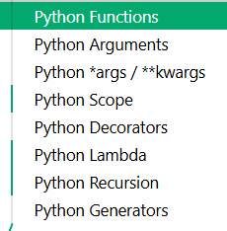
- Conditions

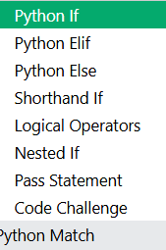
- List,dict,tuple,sets

- OOP

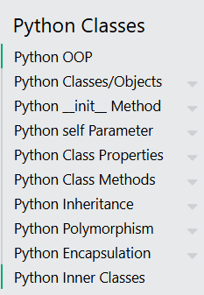

Python Scope

Scope
Jis region main hum nay variable ko create kia h wo variable srf usi region say accessible ho ,this is called scope of a variable.

Local Scope
Agar hum nay aik variable function k anadr create kia h to us variable ka scope local h ,us variable ko srf function k andr he use kia jaa skta h

Function Inside Function
Agar aik variable hum nay aik function k andr ceate kia h or us same function k andr aik or function h to wo variable inner function main b accessible h, aor agar variable inner function main create kia gia h to wo variable outer function main accessible nai h

Global Scope
Aik variable jo k function say bair create kia gia h wo pury code main kahen b accessible h

Naming Variables
Agar hum do varaibles define krty hain aik local scope main or aik global scope main both with the same naming to python un dono varaibles ko 2 seprate variables many ga function k and local scope wala variable he use ho ga or bair global scope wala

Global Keyword

We use global keyword in two scenarios:
1.when we need to update value of a global variable inside a function
2.when we need to convert a variable created inside a function (local scope to global scope)
- Jab hum ny variable outside the function create kia ho or us ke value ko
Update inside the function krna pry to python us ko new variable smjh leti h jo k local scope par create kia gia h is liy us k sath global keyword use krty hain taaky python kop ta chaly k yeh whi same variable h

Nonlocal Keyword
Nested functions hain (yani aik function k andr dusra function h) , outer function main jo variable bnaia gia h us ke value ko inner function main update krna h to inner function us outer function k variable ko apna varaioble smjh ly ga is case main inner function ko yeh btanay k liy k yeh varable outer function ka h tumhara nai to Nonlocal keyword use krty hain

The LEGB Rule
- Local : cuurent function k andr jo variable create hoa
- Enclosing:nested fundtions main jo variable outer function main define hoa h
- Global: function k bair jo variable define hoa
- Built-in : pythin k built in names like print,str,len etc
- Function : print,len
- Type:str,int
- Constant :True,false
Example : print aik function h (python main built in ) lkn python usy us k name k through dhuntatta h built-in scope main
Sab sy phly local variable chk hota h ,then enclosing and then global or phir built-in scope chk hota h python hmesha nearest scope wala variable use krti h like
Agr hmary pass aik glabal scope main x h or aik local main to local jesa k sab sy phly chk hota h to pythin local scope wala variable he use kry ge

Python Recursion

Recursion
aik function jo apny andr (apni body main) khud ko he call krta h again and again until a stop condition met.(it breaks a big complex problem in to simple subproblems)
We can use as an alternative of loops but for complex problems like trees, folders, puzzles we should use recursion instaed of loops

Base Case and Recursive Case
every recursion function should must have two parts
- Base Case:the condition we use to stop recursion
- Recursive case:the case when function call itself with a modified argument
Without base case a function will keeps calling itself forever and it will cause stack overflow error.
stack overflow error:
stack over flow error tab hota h jab function khud ko infinite time call krta rehta h and us sy memory fill up ho jati h (call stack memory) tab tk jab tk system crash na ho jay ya execute hona band na ho jay
It usually occurs in recursion when there is no proper base case or too deep calls.

Fibonacci Sequence;
Fibonacii sequence classic example h jahan hum recursion use krskty hain is main har agla number pichly do numbers ko sum kar k milta h
To is sequence main agr humy koi specific number find krna h to hum whahn recursion use krskty hain

Recursion with Lists
Hum recursion ko lists process krny k liy b use kr skty hain by handling one element at a time

Recursion Depth Limit
Python ke is par limit hoti h k kitni deep recursion jaa skti h , default limit 1000 recursive calls hoti hain
We can chk the limit by importing sys and using .getrecursionlimit()
We can increase this limit but can use iteration for a very deep recursion
Interview questions:
Q1
What is recursion in your own words?(already covered)
Q2
What are the two required parts in every recursive function? (already covered)
Q3
What happens if base condition is missing? (already covered)
Q4
Can you explain what happens in memory when recursion runs, like what stack is used and why calls are stored?
what stack is used?
Python uses call stack(run time stack) ,it’s the part of memory wich track function calls
why function calls are stored?
To avoid overwriting of data of functions
what happens in memory when recursion runs?
har call stack main as a new frame push hoti hain jesy he base condition met hoti h frames stack say bair aana shru ho jati hain reverse order mian matlba jo call end par stack main gait hi wo phly bair aati h bcz stack works on LIFO
stack agar bhot ziada bhar jay to stack overflow eror aajata h(asa tab hota h jab hum ny base condition he nai de hoti)
Q5 What is the difference between iteration and recursion in simple words?
- Recursion is alredy covered and
- iteration is when we reapeat steps using loops like for and while loops
- without function calls again and again
- stops when condition met
Q6 Which one is more memory efficient, recursion or iteration, and why?
Iteration is more memory efficient bcz yeh stack frames use nai krti like recursion
In recursion hum har call ko memory main as a frame store krty hain space increase hony ke waja sy memory ziada use koti hai
Q7 What is a base case? Give one simple example in words, no code.(already covered)
What is stack overflow error? Explain in 2 lines only.
It happens bcz of infinite function calls ,infinite function calls will fill the call stack memory it usuly happenes bcz of no proper base case or too deep recursion
Q9
What is meant by “recursive call”? One line only.
When a function calls itself with a smaller or modified argument or input
Q10.Why do we usually pass a smaller value (like n-1) in recursion? One clear reason.?
to move towrd base case (to reduce the problem)taaky recursion ko stop kia jaasky
Q11
What will happen if you write a recursive function that reaches base case, but you forget to return the result?
Base condition ko meet karny k baad result eturn na krny ke wja say function None return kry ga ,jis wja say result wrong ya useless ho skta h
Q12
Can every recursive problem be solved using iteration?
Yes but sometimes it becomes harder to write the problem using iterartion
Q13.Which type of problems are better suited for recursion? Give 1 example in words.?
Recusrion aisi problems k liy best h jin problems main un ko smaller subproblems main break kia jaata h
Examples:fabbonaci sequence , traversal trees,factorial
Q14
Why is recursion sometimes considered slower than iteration?
Recursion is slower because each function call adds overhead and uses stack memory, while iteration avoids that.
Q15
What is recursion depth?
Recursion(function calls) depth is how deep recursion can go or total number of a function’s nested calls in the given time

Lambda Function:
Lambda small anonymus function hota h
Is main any number of arguments ho skty hain lkn number of expression aik he hota h
Syntax:
Lambda arguments:expression
Example:
X=lambda a,b:a+10+b
- Better use of lambda function is to use it as an anonymus function inside a normal function when we give a number as an argument to the normal function and we need to multiply that argument with an unknown number
- We can also use it with built in methods like map(),filter(),sorted()
- If your function is one line and used once use lambda and if your function is complex use normal function with def keywrd
- We can use it like :
sorted_nums = sorted(nums, key=lambda x: x % 10)
- key just as by what rule I should sort the list and lambda is quick anse to that question
- x is taking each number one by one from the list

Decorators:
Decorator is a function that add extra feature to a function without chainging its code we can write it as @shout

Generator
A function that returns one value at a time instead of all at once
The keywrd yield make it a generator
Key difference from normal functions:
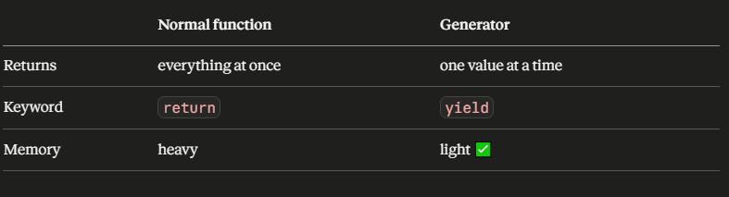
LOOPS IN PYTHON:
we use only two types of loops in python
- for loop
- while loop

Python For Loops:
- we use for loop as an iterator to iterate over sequences like list,tuple,dict,set,string .we can iterate over each elemnt inside list,tuple etc using ofr loop
- yeh loop har item par same kaam repeatedly automatically krti h
- The for loop does not require an indexing variable to set beforehand.
- Matlab hum for loop main items par kaam krty hain indexes manualy mange nai karty
- Like in few languages we use
- I=0
I++
Humy python main asa krny ke zrurat nai hoti q k python isy khud handle krta h

Looping Through a String
Even strings bhi iterable objects hoti hain in main sequence of characters hota h

The break Statement
Using “break” statement we can exit the before it iterarte over entire sequence

The continue Statement
Using “Continue” statement we can skip the current or the specific iterartion and continue with the rest of iterations

The range() Function
- To loop through a set of code a specified number of times, we can use the range() function,as we use i++ in js
- The range() function returns a sequence of numbers, starting from 0 by default, and increments by 1 (by default), and ends at a specified number.
- Note that range(6) is not the values of 0 to 6, but the values 0 to 5.(n-1)
- By default 0 sy start hita h lkn hum strating value specify bhi kr skty hain as a frst parameter
- Or increment by default 1 hota h lkn us ko bhi specify kia jaa skta h as a 3rd parameter

Else keyword in For Loop
- We can also use “else” keywrd insode for loop
- Else code block tab execute hota h jab for loop completely execute ho chuki hoti h
- The else block will not run if for loop was stopped by break statemnet

Nested Loops
- A nested loop is a loop inside another loop
- If we have two loops Outer loop runs frst and the inner loop will run for each iterartion of outer loop repetedly.

The pass Statement
We cant use empty for loop so if in case we need an empty for loop we can use pass statement just like in functions

The while Loop
- While loop use kr k hum tab tak statemnts execute kr skty hain jab tak condition true h
- Is loop main humy i ko increment krna parta h agar nai kren gy to infinite loop
- Is loop main indexing bhi krni prti hai jo k for loop main nai krni parti

The break Statement
Same as in for loop

The continue Statement
Same as in for loop

The else Statement
Same as in for loop
Python Lists,Python Tuples,Python sets,Python dictionaries
Notes on the link :
https://claude.ai/public/artifacts/099238d3-4c90-4def-8c44-716cf53eb4bc

hashable :
- a value that cannot be changed
- imutable datatypes are hashable
- mutable datatype are not
• dict and set are NOT hashable
• their elements (keys in dict, items in set) MUST be hashable

Python Conditions and If statements
Python supports the usual logical conditions from mathematics
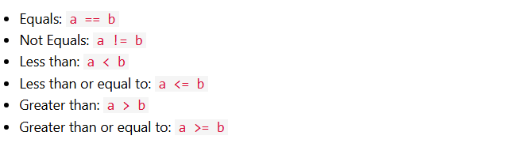
These conditions can be used in several ways, most commonly in "if statements" and loops.

Indentation
The white spaces at the beginning of a line to define the scope in the code

Multiple Statements in If Block
We can have multiple print statemnets inside an if statement

Using Variables in Conditions
- We can also used boolen variables inside if statemnets instead of using comparison operators ,we can store BOOlean variable directly in a variable and then use that variable instead of using comparison operator
- Python can evaluate many types of values as True or False in an if statement.
- False: (0),””(empty string),None and empty collections
- True:”False” ,non empty strings,positive numbers ,negative numbers

Python Elif Statement

The Elif Keyword
- We use Elif when we want to say that if the previous condition or conditions were not true then try the nxt condition
- Elif multiple statements chk krta h agr if block wali condition true nai h to elif wali jo k nxt condition h wo chk ho ge
- Agr wo b true nai h to us sy nxt wali chk ho ge
- Is trah condtions tab tak chk hn ge jab tak wo wali condition jo true h wo nai mil jaati jesy he true wali condition mil jaati h to nxt wali saari conditions skip ho jaien ge

Multiple Elif Statements
We can use multiple Elif statements python sab conditions ko aik order main chk kry ge or whi condition execute kry ge jo sab say phly true hoe h baakion ko skip kr dy ge

How Elif Works
Python conditions ko top sy bottom chk kry ge or tab tak chk kry ge jb tak usy true condition nai mil jaati jesy he mily ge usy execute kr dy ge baaki sab main agr koi or condition true h b to usy skip kr dy ge Execute usi condition ko kry ge jo sab sy phly true hoe h

When to Use Elif
Elif tab use krni chaoy jab aap k paas multiple conditions hn chk krny k liy or yeh ziada effeicientway h as compare to using multiple if statemnts bcz python chk krna stop kr deti h is main jesy he true statement milti h

Python Else Statement
- Agar Elif ke sari conditions false ho gaien hain to last par aik else block lgy ga jis main koi condition nai ho ge to is case main wo else block he run ho ga
- Ya hum srf isy if statement k sath use kr skty hain
- If-Elif-else chain main else hmesha end pr use ho ga
- Else as a fallback use hota h jab preceeding sari conditions false ho jaati hain
- Yeh error handling,validation or default value provide krny k liy useful hota h

Python Shorthand If

Short Hand If
Agr aap k paas srf aik statement h excute krny k liy to aap us statement ko if wali same line pr likh skty hain,lkn app ko still : colon ke zrurat ho ge

Short Hand If ... Else
- Agar aap k paas aik statement if k liy ha or aik else k liy to uno ko b condition lga kr same line par likah jaa skta h
- Like
print("A") if a > b else print("B")
- agar conditional expression true hto phlli statmnt execute ho ge else lastw ali
- This is called a conditional expression (sometimes known as a "ternary operator").

Assign a Value With If ... Else
Aap one lineif/else is liy bhi use kr skty ho k wo single line if/else aik variable ko assign kro or aik value conditional operatr ke base pr choose kr k us variable ko wo value assign kr doBasically wo variable hum ny value assign krny k liy bnaia hota h
Syntax
variable = value_if_true if condition else value_if_false

Multiple Conditions on One Line
Hum mulitiple condition expressions ko chain bhi kr skty hain but keep it short for code readability
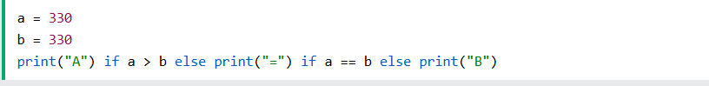

When to Use Shorthand If

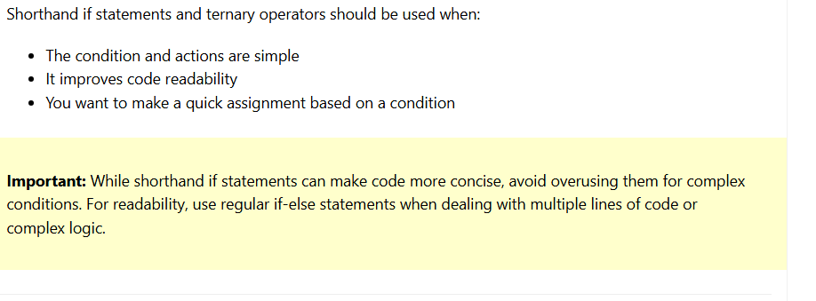

EXTRA POINT:
Another name for one line if –else statement is conditional expression or ternary operatr

Python Logical Operators
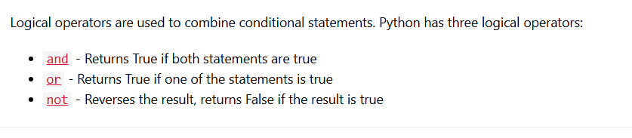

Python Nested If

Nested If Statements
An if statement inside another one

How Nested If Works
Har level of netsted loops deep decision making create krta h .neted loops main sab say phly bair waali yani outer most if statement ka code evaluate hota h (outermost to inward evaluate hota h)

Multiple Levels of Nesting
Hum jitni marzi if statemnts nest kr skty hain lkn nesting jitni ziada deep ho ge utna ziad code read krna mushki ho jay ga

Nested If vs Logical Operators
Nested if ke bajay hum sometime code readability k liy logcal operatrs b lga skty hain like “and”
and ya koi b logical operatr nested if e bjay tab he lgao jab statemnts simple hn or equaly important b

pass statement

yeh null operation hota h yeh krta kuch nai h bs is ko as a place holder use kia jaata h jab aap program ka structure ban rhy ho lkn logic implement baad main krna h

Match Statement

we can use match statement instead of writing many if – else statements it works like switch statement(in other languages)

yeh srf aik code block ko condition ke base par selct krti h

we can use underscore as the last case value jo tab chly ga agr upper usy koi matching case nai mia last block jo underscore k sath hota h usy wildcard case kehty hain

Difference between function & method

Function is a satndalone code its independednt not tied to a class or object

while methods are always dependednt on a class or instance/object(they work inside a class)

we call function alone by its name func_name()

we call method by suing a dot notation

object.meth_name()

difference beween module and library??
Module is a single pre-wriiten pythin file we import and use
Library is collection of modules

